***IntelliJ IDE – Exploration***

***Udemy Course: course/master-intellij-idea-become-a-productive-java-developer***

***Pre-Requisites***

***JDK Installation in Windows – JDK Current Latest Version is 22***

*Path:* [*https://www.oracle.com/java/technologies/downloads/#jdk22-windows*](https://www.oracle.com/java/technologies/downloads/#jdk22-windows)

***IntelliJ IDE Installation***

*Path:* [*https://www.jetbrains.com/idea/download/download-thanks.html?platform=windows*](https://www.jetbrains.com/idea/download/download-thanks.html?platform=windows)

***Installing JDK In Windows***

*After downloading the JAVA – When we double click on the installer, we will get the below screen.*

*Click on next.*

*Click on next.*

*To make sure java has been installed successfully.*

***Trouble Shooting issues in Installing JDK***

*To overcome the above issues, we need to set the PATH in the environment variables.*

***Installing and setup IntelliJ Idea IDE***

*Click next.*

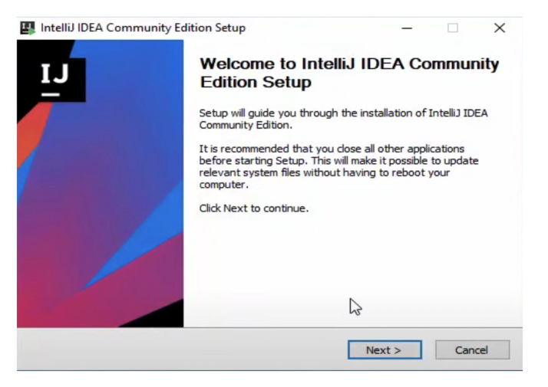

***Click next.***

***If we want we can give configurations in the above window as per our requirement***

***Click next.***

*Select the theme which we want and click on skip remaining and set defaults*

*Click on create new project., after that we can specify the JDK Version required, Maven or Gradle project and give next*

*Click on finish.*

*Once the build is successful, we will see the green tick mark over here*

***Exploring IntelliJ IDE***

***Installing Presentation assistant, Keymaps and learning Keyboard Shortcuts***

***Going to keymaps inside intelij idea***

*Keymaps are nothing but the set of predefined shortcuts. select the appropriate shortcuts from the dropdown menu.*

*Presentation assistant is the plugin through which we will be able to get to know lot of keyboards shortcuts*

*Click on install and give apply. After giving apply, we will be able to see the presentation plugin under appearances.*

***How to change fonts to editor and console***

*Go to intellij IDEA ->Preferences -> Editor ->font*

*Changing the console font [go to IntelliJ IDEA ->Preferences ->Editor ->Color Scheme –*

*>console font]*

***How to change the themes and appearance of the IDE***

*On click that option above, we will be getting the option below.*

*On clicking the Edit Color Scheme, we will be getting the below options.*

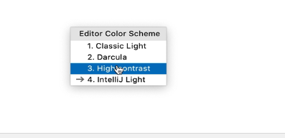

*On selecting the Dracula, we will be end up with Dark color theme*

*Customized themes can be applied by navigating to the below highlighted path*

*Click on the search and select the appropriate theme and just install it to your IDE*

*After clicking on the install, it will show the below popup in the IntelliJ IDE*

***Alter the appearance of the IDE For maximum productivity.***

*Dock unpinned in the view mode, in which the window wont be visible unless and until it is active*

*After that once we move to the editor, we will be able to see the editor with the maximized size.*

*To save the customized window changes we need to click on the below option.*

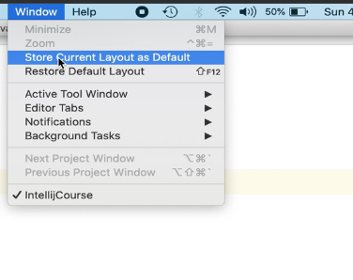

***Using IntelliJ IDEA Without Mouse***

*To open the specific window (For example like project, the short cut used in windows is ALT+number)*

*Every window has been associated with the number.*

*To navigate over the files and go into the specific directory -> make use of the up and down arrows and press enter to move into specific directory.*

*To move to the editor tab press escape key.*

*Shift +f12 -> Restore to default Layout*

*We can add shortcut for a specific Menu.*

***How does intellij auto import work? How can you remove unused Imports.***

*Shortcut for windows to remove the unused imports -> Alt + enter key.*

***Reference URL :***

[***https://embarkx.com/***](https://embarkx.com/)

[***https://www.jetbrains.com/help/idea/2016.1/version-control-with-intellij-idea.html?origin=old_help***](https://www.jetbrains.com/help/idea/2016.1/version-control-with-intellij-idea.html?origin=old_help)

[***https://dev.to/doabledanny/git-cheat-sheet-50-commands-free-pdf-and-poster-4gcn***](https://dev.to/doabledanny/git-cheat-sheet-50-commands-free-pdf-and-poster-4gcn)